A000-EUR-France-Paris Basin-Mousterian-Levallois method-Flint-Mid Paleo-100-30 kya

flint blond white patina of the Paris Basin Middle Paleolithic. period of the Mousterian type of debitage Levallois method 100.000 TO 30.000 BC

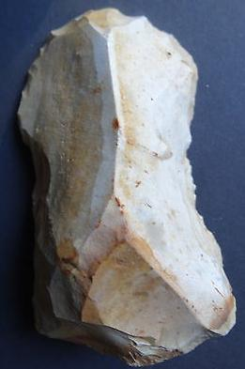

Case no.:

Accession Number:

Formal Label:

**Display Description:**

**LC Classification:**

Date or Time Horizon:

Geographical Area:

**Map:**

**GPS coordinates:**

Cultural Affiliation:

Media:

Dimensions:

Weight:

Condition:

Provenance:

**Discussion:**

**References:**